https://github.com/Petermatovu/QN2VUPAY.git
QTN 2
a) Why inheritance becomes problematic
The inheritance design uses separate classes such as CashPayment, BankPayment, MobileMoneyPayment, CardPayment, ChequePayment.
This becomes problematic because:
- The new requirement allows split payments, but inheritance assumes one payment type per class.
- Changing verification rules requires modifying subclasses and recompiling the system.
- Adding new payment methods creates many subclasses (class explosion).
- Integration with external APIs requires flexible behaviour, which inheritance does not support well.
Therefore, inheritance makes the system rigid and difficult to maintain
(b) New design using composition and polymorphism
Instead of inheritance, the system should use composition, where a payment contains multiple payment methods.
(i) Classes / Interfaces
- PaymentMethod (interface)
- BankMethod, MobileMoneyMethod, CashMethod, CardMethod, ChequeMethod
- VerificationStrategy (interface)
- Payment
- PaymentProcessor
- Receipt
(ii) Responsibilities
- PaymentMethod: defines how a payment is processed.
- Concrete methods: implement payment behaviour.
- VerificationStrategy: handles verification rules separately.
- Payment: holds multiple payment methods (supports split payment).
- PaymentProcessor: processes payments and generates receipt.
- Receipt: displays final payment information.

(iii) How split payment is supported
The Payment class stores multiple payment methods with their amounts.
Example:
A single payment can include Bank + Mobile Money.
Each method processes its part and the system generates one receipt.
Pseudocode
Payement of UGX 120,000 split:
40% Bank, 60% Mobile Money

total = 120000
payment = new Payment()
payment.addMethod(BankMethod, total * 0.40)
payment.addMethod(MobileMoneyMethod, total * 0.60)
processor = new PaymentProcessor()
receipt = processor.process(payment)
receipt.print()
The system processes each method and produces one consolidated receipt

d) Two design mistakes
1. Putting verification inside payment classes
- Makes rule changes difficult
- Requires code modification
- Reduces flexibility
2. Using inheritance for payment combinations
- Leads to too many classes
- Hard to extend
- Cannot support dynamic split payment
SECTION B
QTN THREE
(a) Constructors vs Garbage Collection (Java vs C++)
Constructor
- A constructor is a special method used to initialize an object when it is created.
- It assigns values to variables and prepares the object for use
class Patient {
String name;

Patient(String name){
this.name = name; // constructor initializes object
}
}

Garbage Collection (Java)
- Java does not use destructors like C++.
- Instead, Java uses garbage collection to automatically remove unused objects from memory.
Example
Patient p = new Patient("John");
p = null; // object becomes eligible for garbage collection
Difference:
- Constructor → creates and initializes object
- Garbage collection → automatically destroys unused objects (memory cleanup)
B) EMR System Example — St. Mary’s Hospital Lacor
At St. Mary’s Hospital Lacor, Java EMR uses object-oriented features.
(i) Using this keyword in constructor
The “this” keyword resolves naming conflicts between instance variables and parameters
class Patient {
String patientId;
String allergyNotes;

Patient(String patientId, String allergyNotes){
this.patientId = patientId;
this.allergyNotes = allergyNotes;
}
}
Without “this”, Java cannot distinguish between parameters and instance variables
(ii) Definitions
(a) Static method (Shared utilities like BMI)
A static method belongs to the class, not an object.
It is used for shared functionality
class HealthUtils {

static double calculateBMI(double weight, double height){
return weight / (height * height);
}
}
Use
double bmi = HealthUtils.calculateBMI(70, 1.75);
Used because BMI calculation is common to all patients
(b) Method overloading (Multiple report formats)
Method overloading allows same method name with different parameters
class Report {
void generateReport(String patientId){
System.out.println("Basic report for " + patientId);
}
void generateReport(String patientId, String doctor){
System.out.println("Detailed report for " + patientId + " Doctor: " + doctor);
}
}

(c) Difference between final and finally
final
- Used with variables, methods, or classes.
- Prevents modification or inheritance.
Example — Medical constants
final class MedicalConstants {
static final double NORMAL_TEMP = 36.5;
}
The class cannot be extended → protects constants
finally
- Used in exception handling.
- Always executes whether an exception occurs or not.
Example — Ensure files close
try{
// generate report
}
finally{
file.close(); // always runs
}
Ensures resources are released.
D)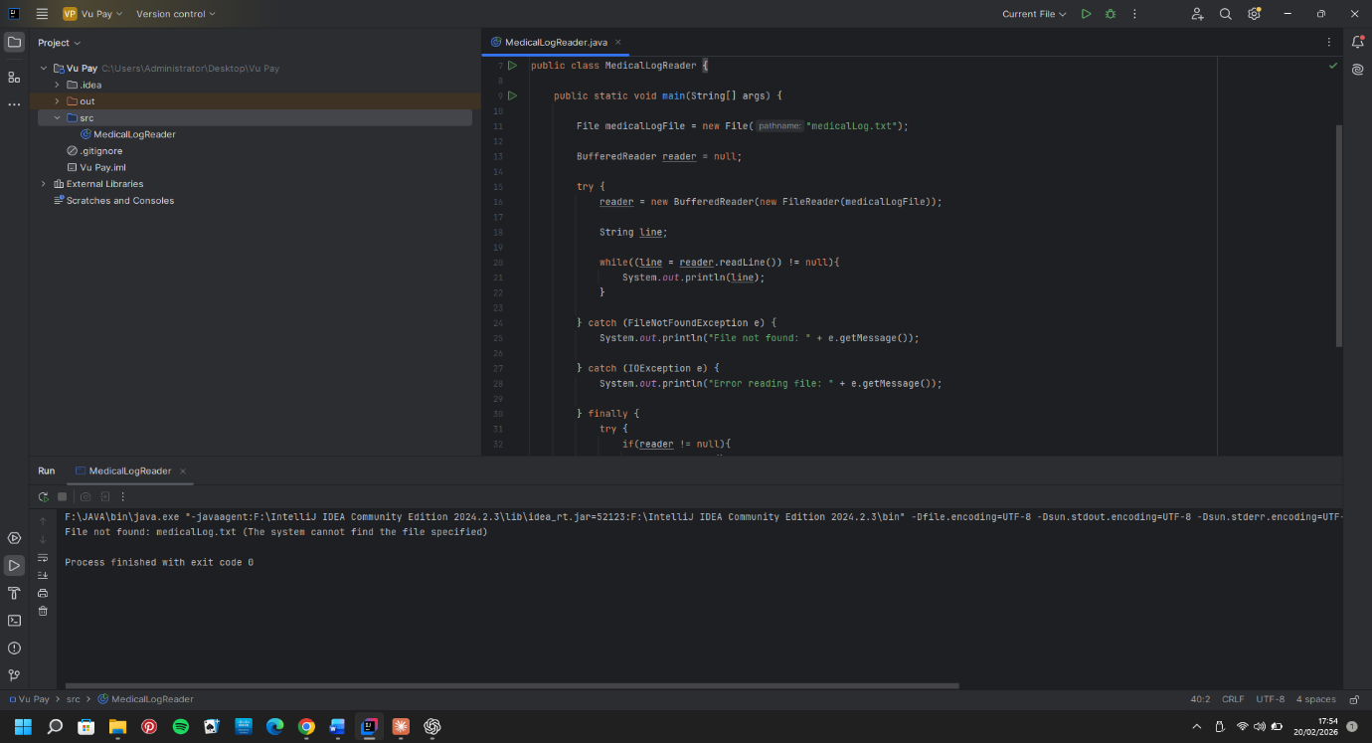
QTN 6
a) Purpose of Access Modifiers in OOP
Access modifiers are keywords in OOP that control the visibility and accessibility of classes, variables, methods, and constructors from other parts of a program. Their purposes are:
1. Encapsulation / Data Hiding — They restrict direct access to sensitive data. For example, a patient's medical record should not be freely modified by any class in the system. Making fields private forces access only through controlled methods (getters/setters).
2. Security — They prevent unauthorized classes from reading or modifying critical fields, reducing the risk of accidental or malicious data corruption.
3. Code Maintainability — By limiting what outside classes can see, you can safely change the internal implementation without breaking other parts of the program.
4. Controlled Inheritance — They allow a programmer to decide what a subclass can and cannot inherit or override, protecting core logic from being accidentally changed in child classes.

b) Access Modifiers Table (6 Marks)
The four Java access modifiers are: private, default (no keyword), protected, and public.
Access Modifier | private | default | protected | public
Defining class | ✅ Yes | ✅ Yes | ✅ Yes | ✅ Yes
Class in the same package | ❌ No | ✅ Yes | ✅ Yes | ✅ Yes
Subclass in a different package | ❌ No | ❌ No | ✅ Yes | ✅ Yes
Non-subclass in a different package | ❌ No | ❌ No | ❌ No | ✅ Yes

private — most restrictive; only the class itself can access it
default — accessible within the same package only (no keyword written)
protected — accessible within the same package AND by subclasses anywhere
public — fully accessible from everywhere
C)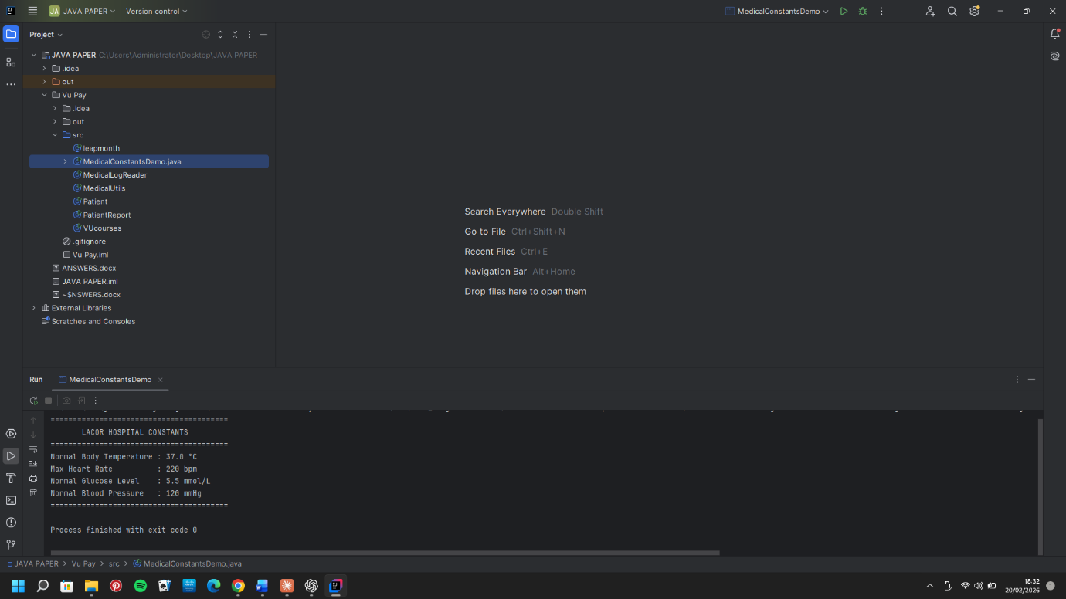
D)